Set 6 Product Sales Analysis
Question 1: Grouped Bar Chart
Code:
sales <- data.frame(
Product = c("Product A", "Product B", "Product C"),
January = c(2000,1500,1200),
February = c(2200,1800,1400),
March = c(2400,1600,1100)
)
data <- rbind(sales$January, sales$February, sales$March)
barplot(data,
beside = TRUE,
names.arg = sales$Product,
col = c("red","blue","green"),
main = "Quarter 1 Product Sales",
xlab = "Products",
ylab = "Sales",
legend.text = c("January","February","March"))
Output:
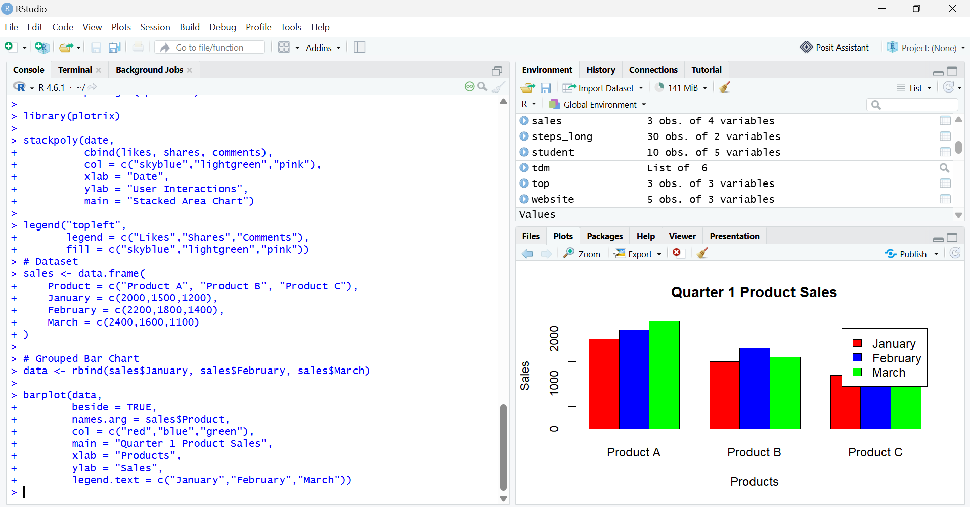

Question 2: Stacked Area Chart
Code:
months <- c(1,2,3)
A <- c(2000,2200,2400)
B <- c(1500,1800,1600)
C <- c(1200,1400,1100)
library(plotrix)
stackpoly(months,
cbind(A,B,C),
col = c("red","blue","green"),
xlab = "Month",
ylab = "Sales",
main = "Overall Sales Trend")
axis(1, at = months, labels = c("January","February","March"))
legend("topleft",
legend = c("Product A","Product B","Product C"),
fill = c("red","blue","green"))

Output:
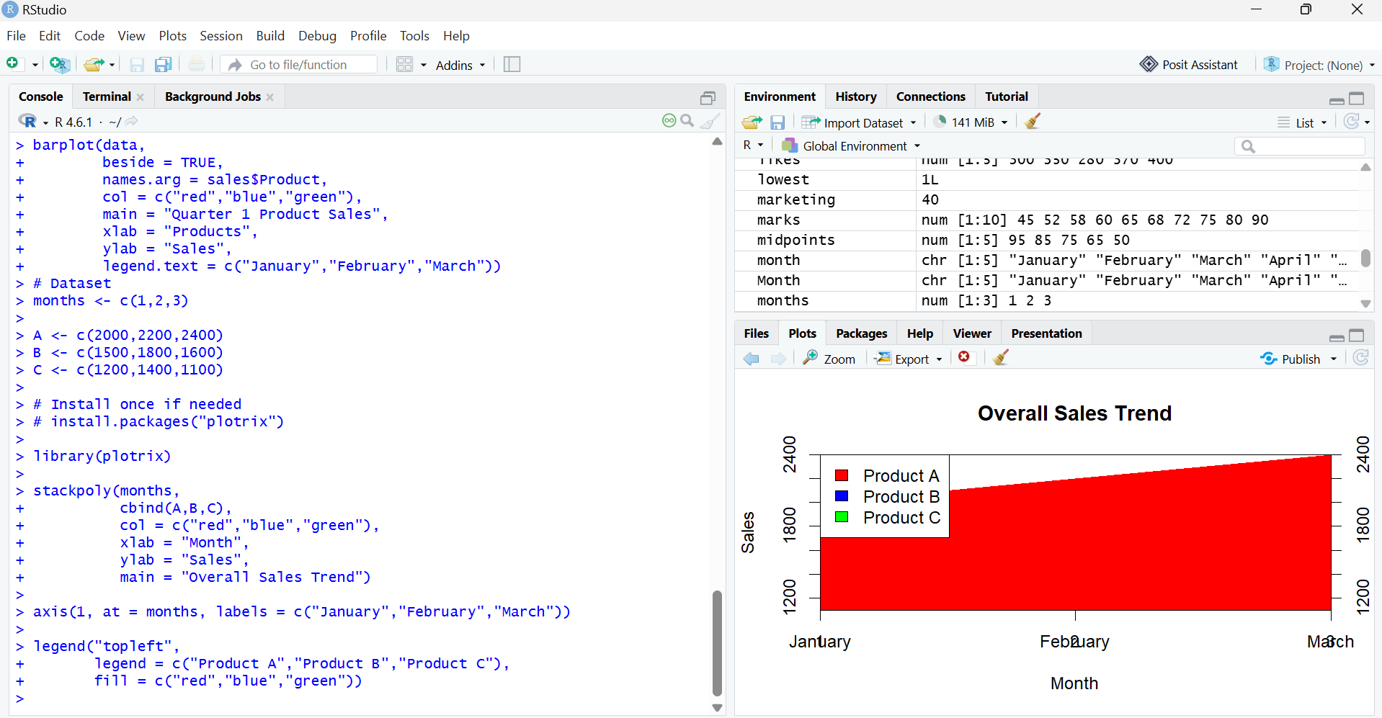

Question 3: Monthly Sales Table
Code:
sales <- data.frame(
Product = c("Product A", "Product B", "Product C"),
January = c(2000,1500,1200),
February = c(2200,1800,1400),
March = c(2400,1600,1100)
)
print(sales)

Output:
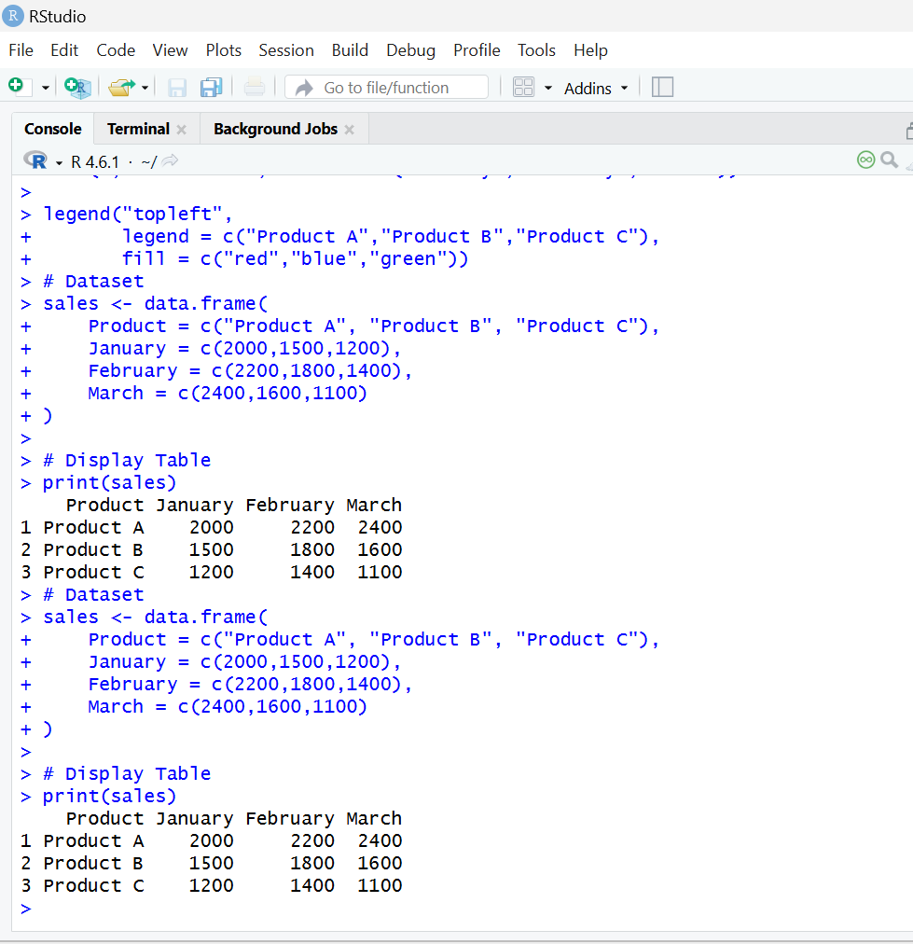

SET 7 – Customer Demographics Analysis
Q1. Bar Chart
customer <- data.frame(
CustomerID = c(1,2,3),
Age = c(28,35,42),
Gender = c("Female","Male","Female"),
Income = c(50000,60000,75000)
)
barplot(customer$Age,
names.arg=customer$CustomerID,
col="skyblue",
xlab="Customer ID",
ylab="Age",
main="Customer Age Distribution")
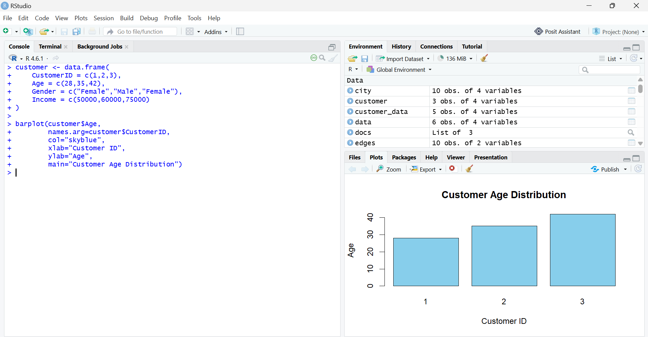

Q2. Pie Chart
customer <- data.frame(
CustomerID = c(1,2,3),
Age = c(28,35,42),
Gender = c("Female","Male","Female"),
Income = c(50000,60000,75000))
gender <- table(customer$Gender)
pie(gender,
col=c("pink","lightblue"),
main="Gender Distribution")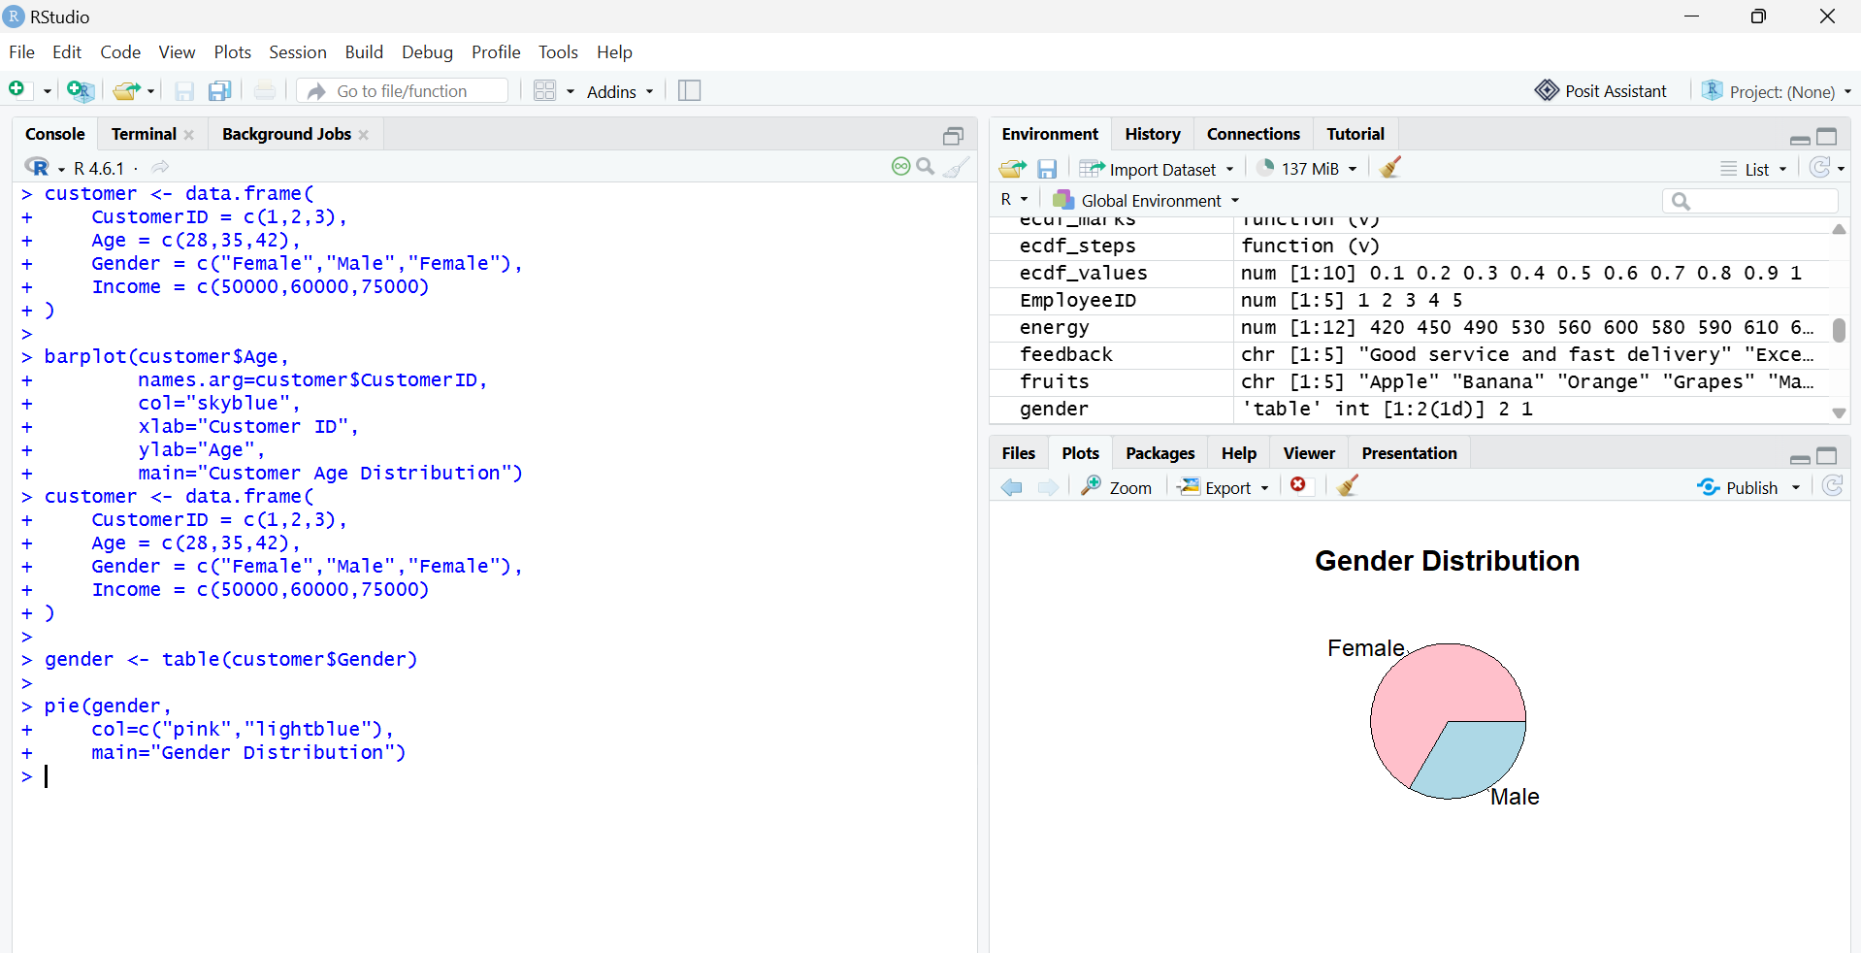

Q3. Table
customer <- data.frame(
CustomerID = c(1,2,3),
Age = c(28,35,42),
Gender = c("Female","Male","Female"),
Income = c(50000,60000,75000)
)
Customer
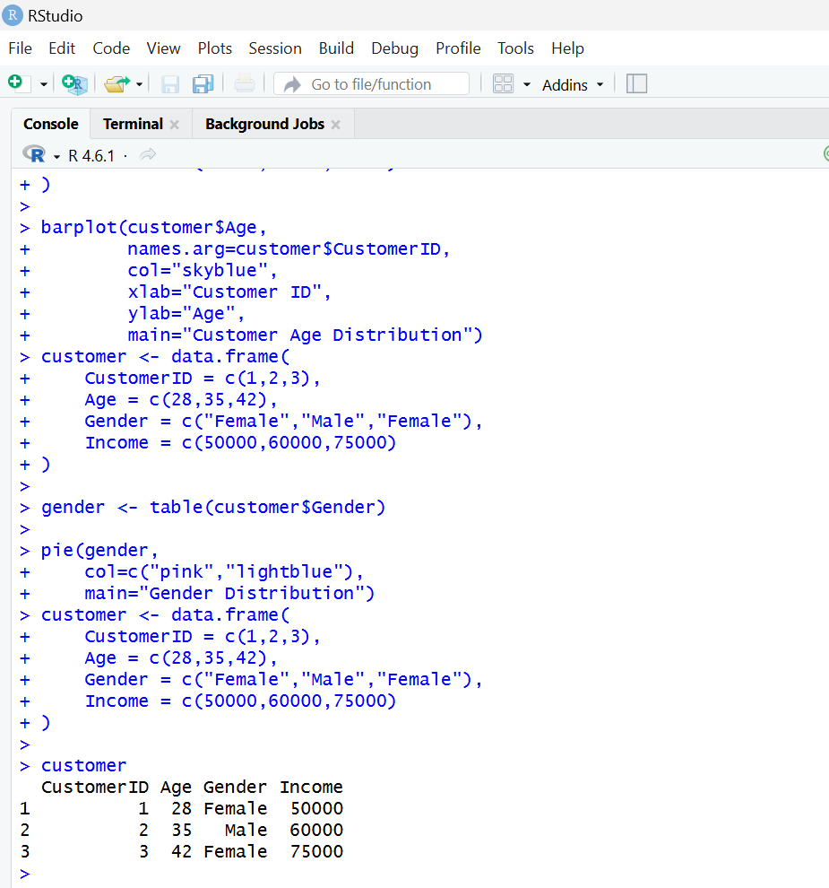

SET 8 – Employee Performance Analysis
Q1. Line Chart
employee <- data.frame(
EmployeeID = c(1,2,3),
Department = c("Sales","HR","Marketing"),
YearsService = c(5,3,7),
PerformanceScore = c(85,92,78)
)
plot(employee$EmployeeID,
employee$PerformanceScore,
type="o",
pch=16,
col="blue",
xlab="Employee ID",
ylab="Performance Score",
main="Employee Performance Trend")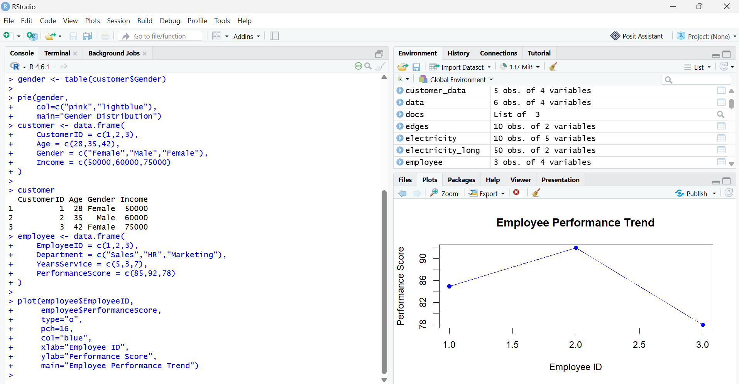

Q2. Bar Chart
employee <- data.frame(
EmployeeID = c(1,2,3),
Department = c("Sales","HR","Marketing"),
YearsService = c(5,3,7),
PerformanceScore = c(85,92,78)
)
dept <- table(employee$Department)
barplot(dept,
col="orange",
xlab="Department",
ylab="Number of Employees",
main="Employees by Department")
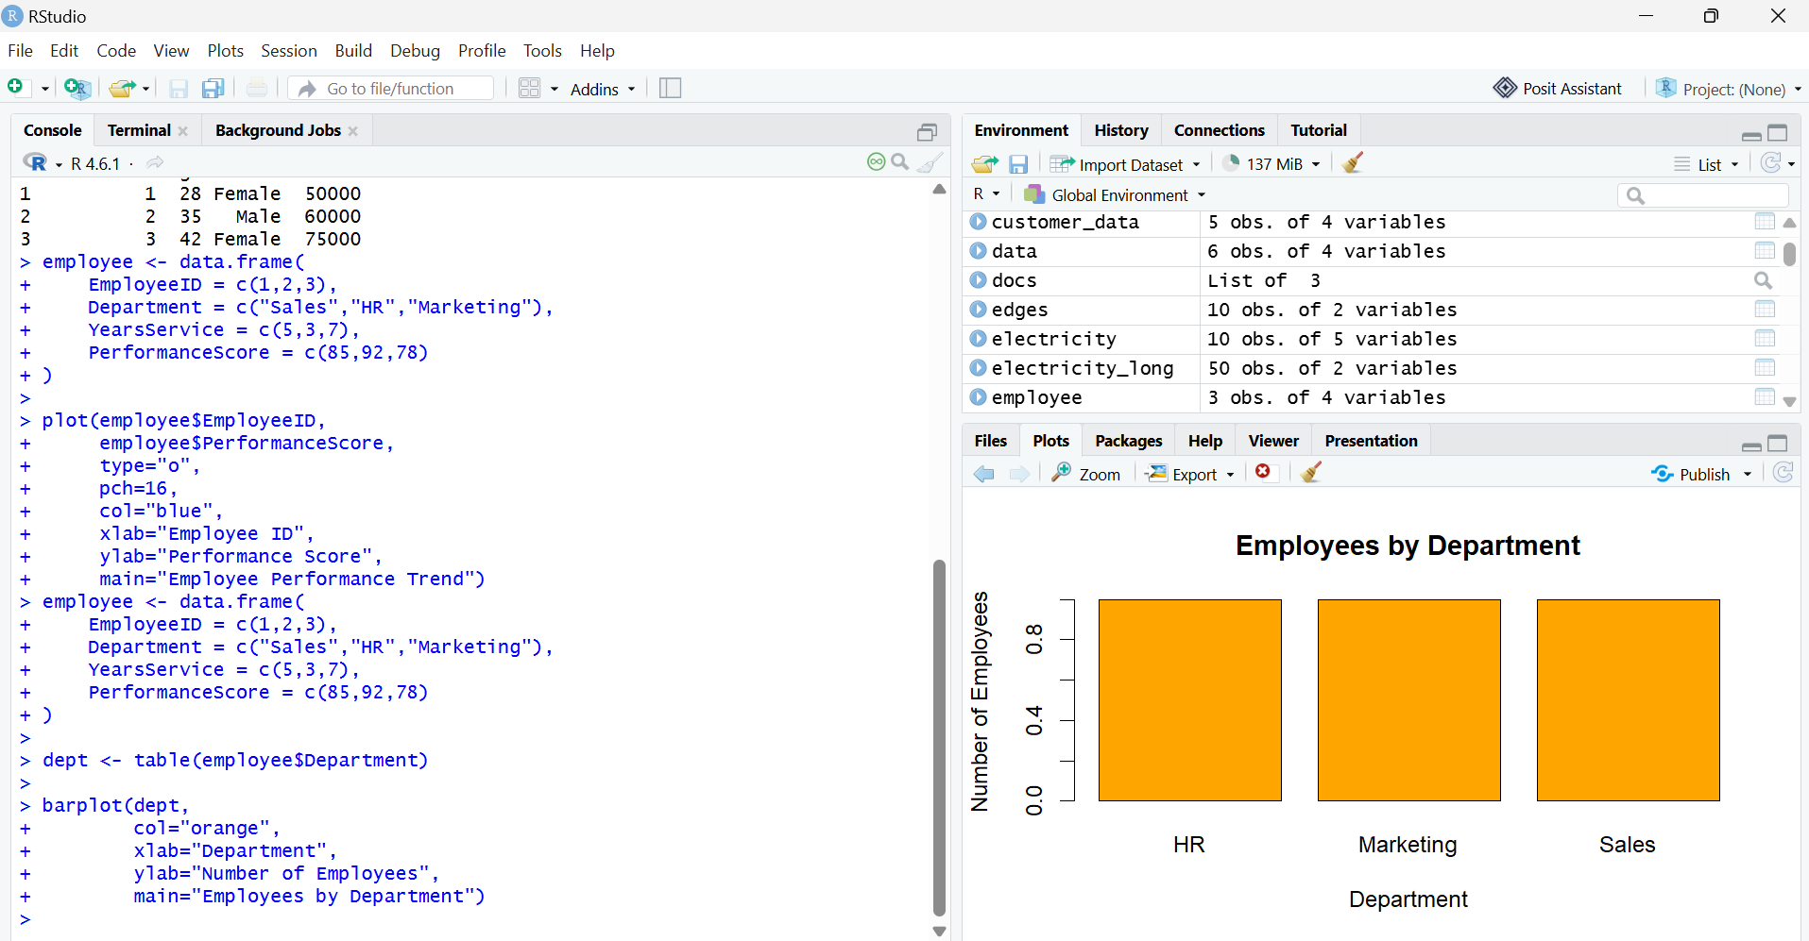

Q3. Table
employee <- data.frame(
EmployeeID = c(1,2,3),
Department = c("Sales","HR","Marketing"),
YearsService = c(5,3,7),
PerformanceScore = c(85,92,78)
)
Employee
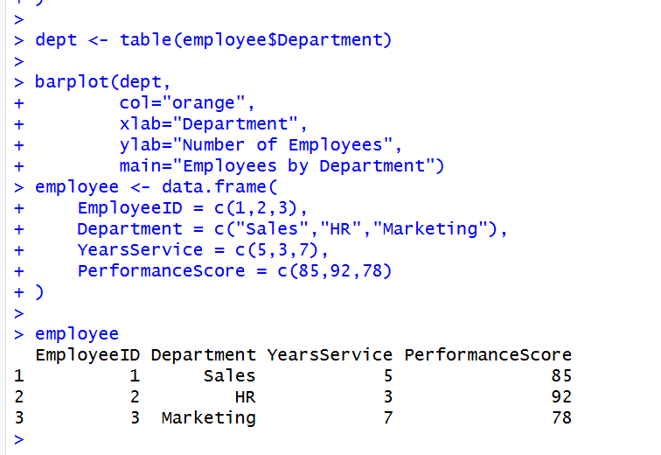

SET 9 – Product Inventory Management
Q1. Bar Chart
inventory <- data.frame(
ProductID = c(1,2,3),
ProductName = c("Product A","Product B","Product C"),
Quantity = c(250,175,300),
Price = c(20,15,18)
)
barplot(inventory$Quantity,
names.arg=inventory$ProductName,
col="lightgreen",
xlab="Product",
ylab="Quantity Available",
main="Product Inventory")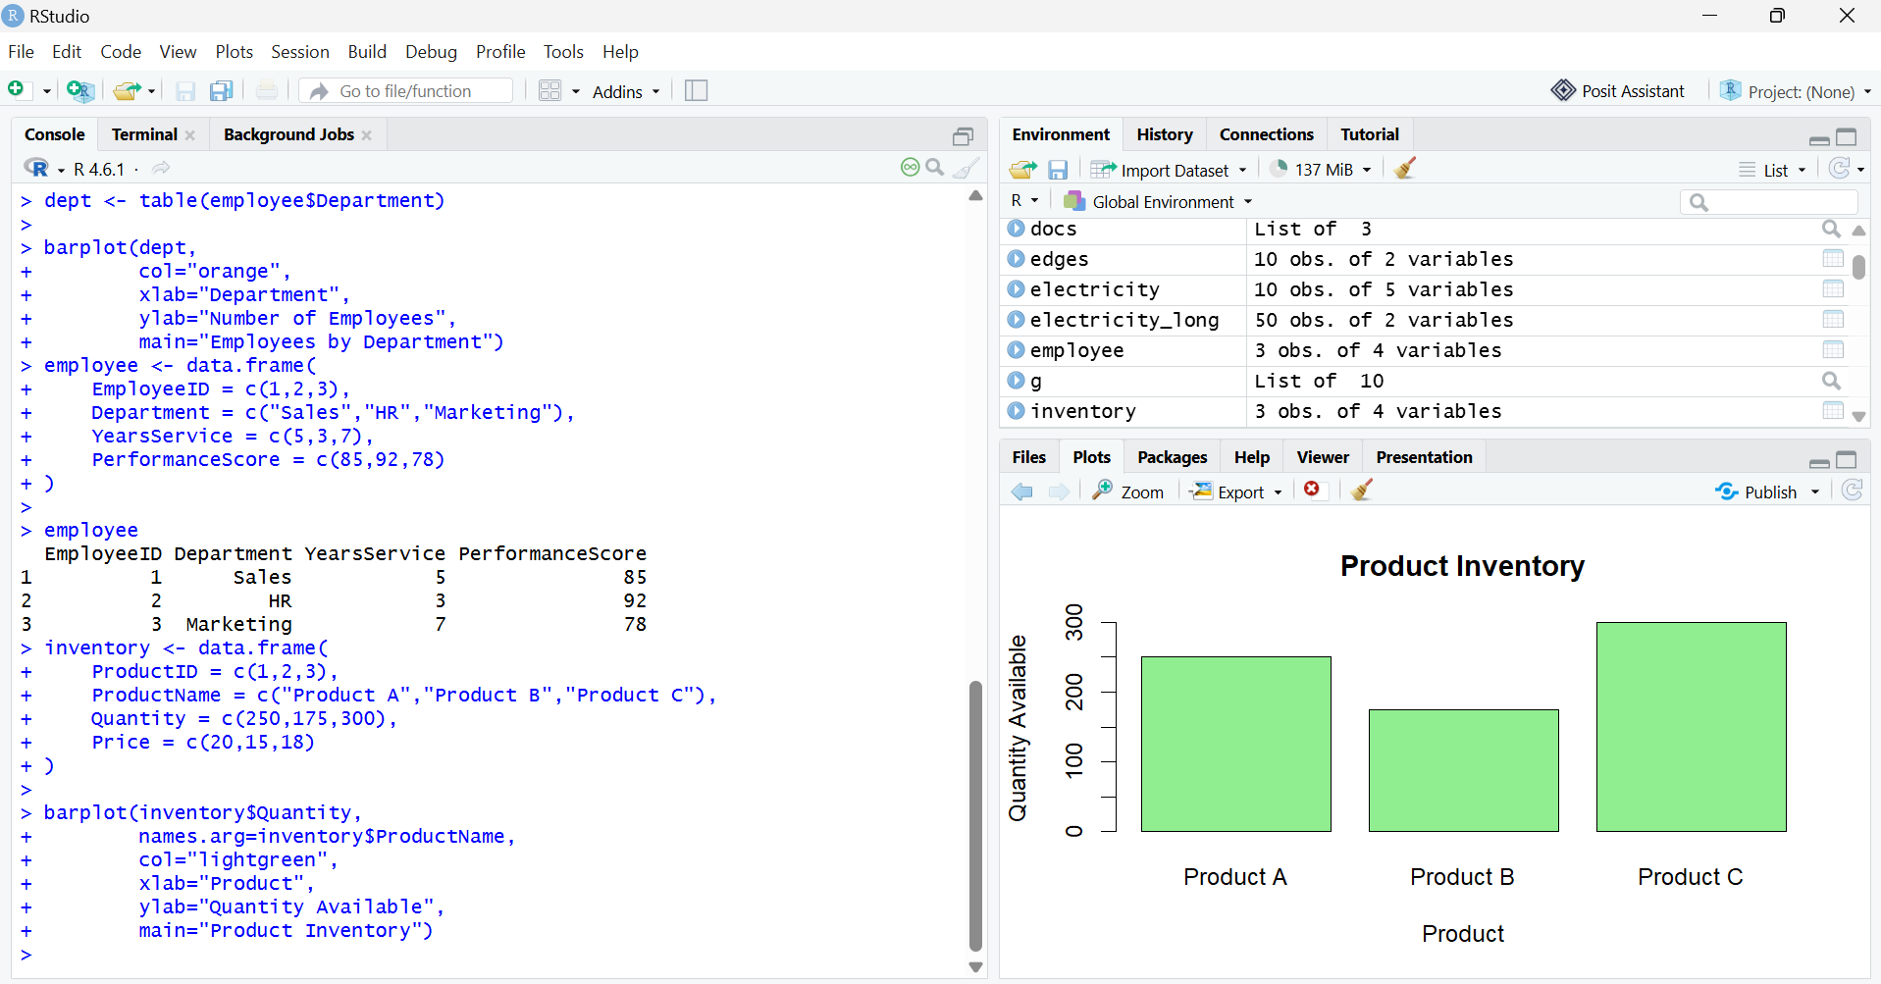

Q2. Stacked Bar Chart
inventory <- data.frame(
ProductID = c(1,2,3),
ProductName = c("Product A","Product B","Product C"),
Quantity = c(250,175,300),
Price = c(20,15,18)
)
data <- rbind(inventory$Quantity)
barplot(data,
col="steelblue",
names.arg=inventory$ProductName,
xlab="Product",
ylab="Quantity",
main="Stacked Product Inventory")
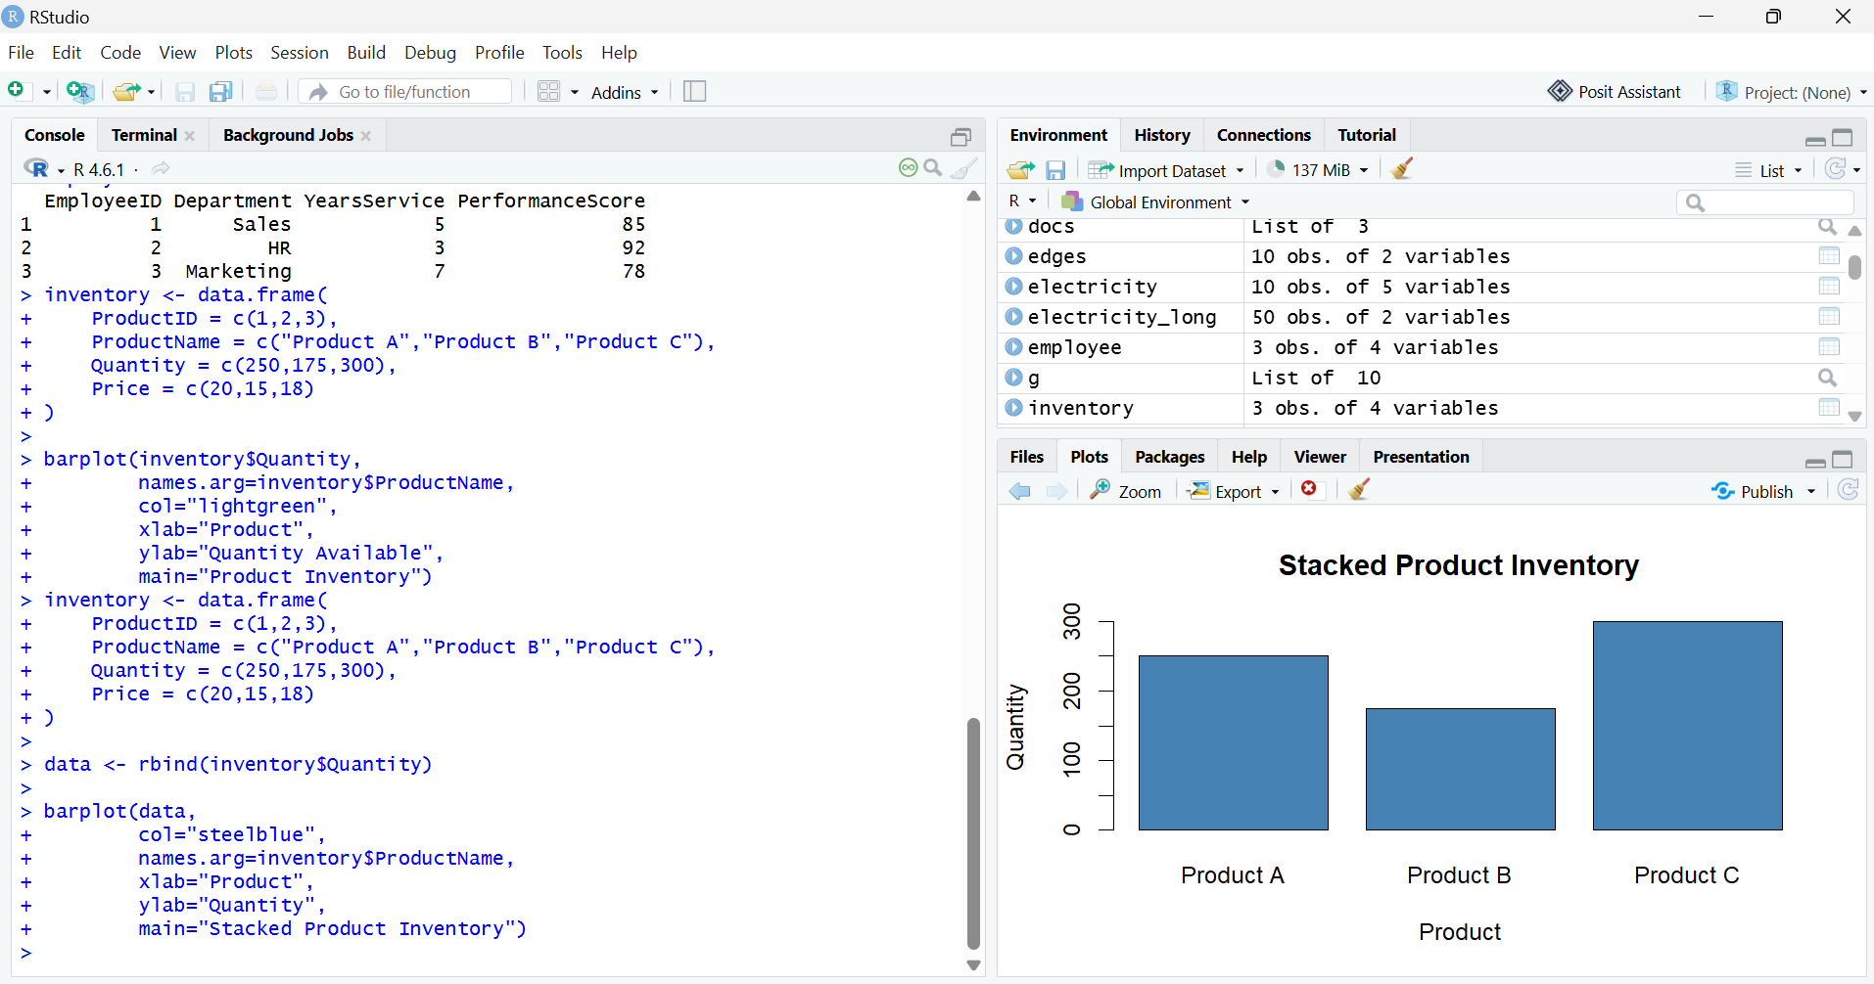

Q3. Table
inventory <- data.frame(
ProductID = c(1,2,3),
ProductName = c("Product A","Product B","Product C"),
Quantity = c(250,175,300),
Price = c(20,15,18)
)
Inventory
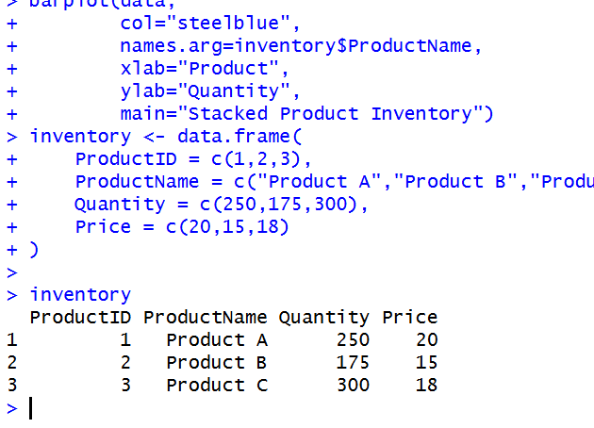

SET 10 – Survey Responses Analysis
Q1. Grouped Bar Chart
survey <- data.frame(
SurveyID = c(1,2,3),
Question1 = c("A","B","C"),
Question2 = c("B","A","D"),
Question3 = c("C","D","B")
)
q1 <- table(survey$Question1)
barplot(q1,
beside=TRUE,
col="cyan",
xlab="Responses",
ylab="Count",
main="Question 1 Responses")
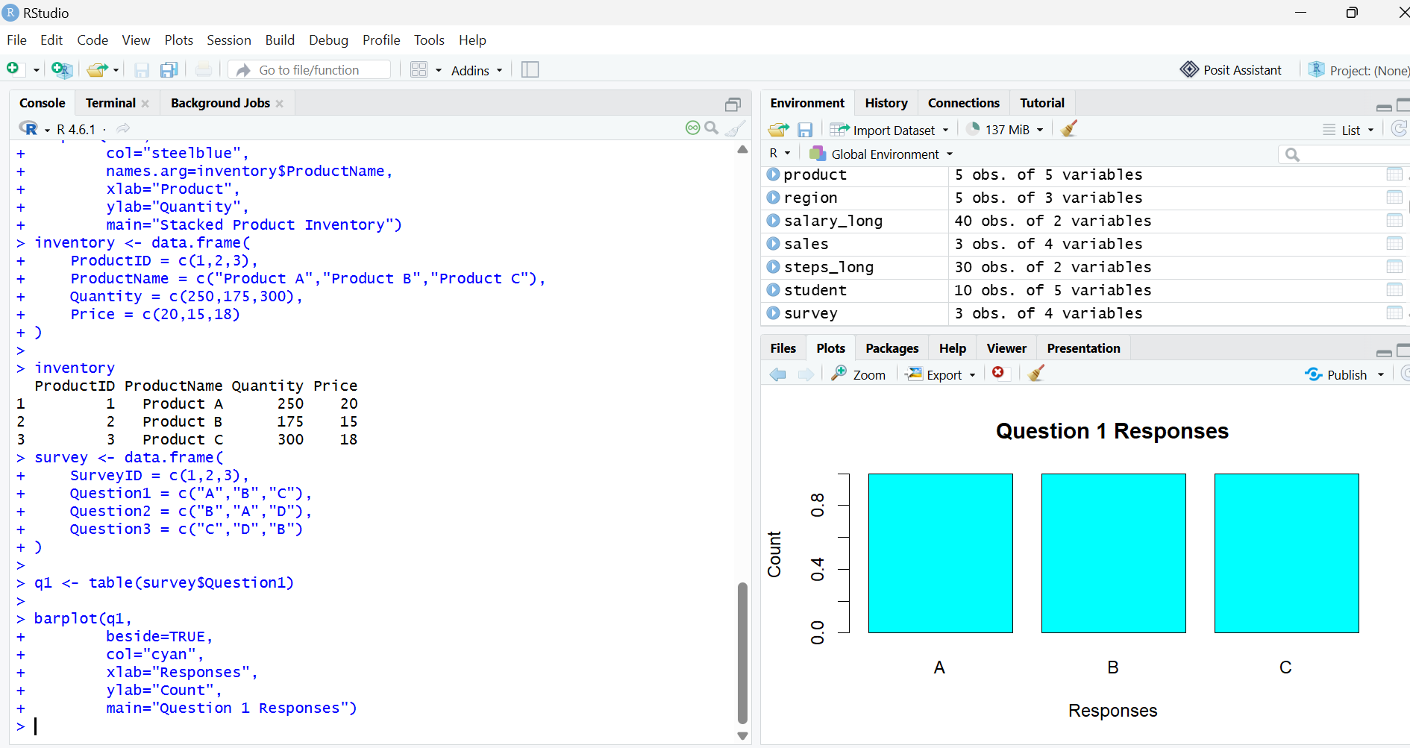

Q2. Stacked Bar Chart
survey <- data.frame(
SurveyID = c(1,2,3),
Question1 = c("A","B","C"),
Question2 = c("B","A","D"),
Question3 = c("C","D","B")
)
q1 <- table(factor(survey$Question1, levels=c("A","B","C","D")))
q2 <- table(factor(survey$Question2, levels=c("A","B","C","D")))
q3 <- table(factor(survey$Question3, levels=c("A","B","C","D")))
data <- rbind(q1,q2,q3)
barplot(data,
col=c("red","green","blue"),
legend.text=c("Question1","Question2","Question3"),
xlab="Responses",
ylab="Count",
main="Overall Survey Responses")
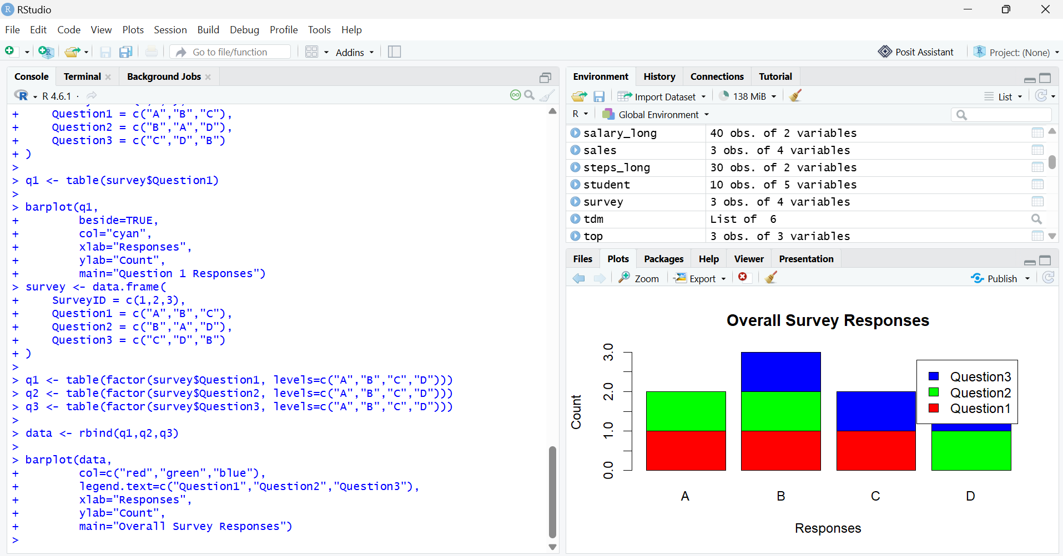

Q3. Table
survey <- data.frame(
SurveyID = c(1,2,3),
Question1 = c("A","B","C"),
Question2 = c("B","A","D"),
Question3 = c("C","D","B"))
Survey
